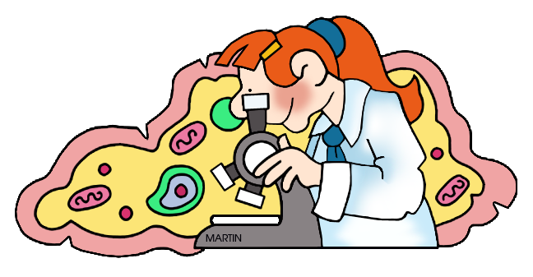
Grade 8 Science
Course Outline 2016 – 2017

Mr. S. Koslowsky
Email: skoslowsky@mbci.mb.ca
Phone: (204) 667-8210 ex. 3205
Be sure to get on Edsby for your marks,
course resources, and student-teacher communication.

Description

The goal of the science department is to develop a critical sense of wonder and curiosity about our world and to increase “scientific literacy.” I look forward to exploring this year’s science topics together with you. The more you involve yourself in what we do in science class, the more you will learn and have fun.

Units of Study *order may change
- Cells & Body Systems (biology)
- Fluids (physics/chemistry)
- Light & Optics (physics)
- Water Systems (ecology)

Materials – Things you need to bring to each class!

Binder, pencil, eraser, pen, ruler, loose-leaf or notebook, scientific calculator, highlighter, textbook as required.

No Phone Policy: Generally you don’t need your phone for class. I will let you know if we need to use phones for research, etc. You will not be allowed to use your phone for tests or quizzes.

The Science Classroom

Science class can be a lot of fun! I hope to have a good time with you as we explore the physical world around us. In order for this to work, we must all be respectful of each other and the materials in this classroom.

Organization & Assignments

Staying organized in a science course is extremely important. I recommend using one of these 2 methods of keeping your binder in order:
1. Chronological -Everything you get goes into your binder in the order that you got it.

2. Categories -Divide your binder into 3 sections:
- Class notes and handouts
- Projects, Assignments, Homework
- Tests and Quizzes (FULLY CORRECTED for exam review)

Many of our labs, projects and assignments will be done in partners or small groups. When this is the case, it is your job to do your best to contribute to the group. It is also your responsibility to make sure you know what is going on so that you are learning. Even when you work in groups, you will all receive individual marks that may not be the same as your group members.

All assignments should be handed in to the Inbox in class. Always use a folder when handing things in.

Tests

We will have tests about once a month. These are not necessarily unit tests, but progress tests based on the material we have covered since the last test. Some cumulative questions will be asked to make sure you don’t forget material throughout the year. I will warn you about cumulative content on tests.

I encourage you to ALWAYS attempt every question on a test. I look through your tests very carefully and usually give part marks if you show some understanding.

You are expected to collect, fully correct, and keep all tests on hand for the exam at the end of the year.

Quizzes

We will have small quizzes frequently, usually on material that has been covered recently.

Evaluation

Overall Mark Breakdown Course Work Breakdown
Course Work 80% Knowledge & Understanding 50%
Final Exam 20% Application & Problem Solving 25%
Communication, Inquiry & Design 25%

Expectations

- Be on time and be prepared. Bring all of the necessary materials to class with you.
- Be diligent. You are expected to complete all of the assignments given to you. The more dedicated you are to your work in this class, the better you will do. Students who fall behind in their assignments will be required to spend the day here at school on “assignment assistance day.”
- Be responsible. If you have to miss a class, it is your responsibility to find out what you missed. If you are absent the day of a test, you will write the test the first day you return.
- Be respectful. Work cooperatively with classmates and treat one another in a Christ-like manner. We are a community of learners that depend on each other for success.
- Be rewarded! I expect that you will “throw” yourself into this class – explore, ask questions, be an active learner. Please know that I will do my very best to make you feel at ease as you learn and experience the challenges of this course. Discover how your gifts help you to get the most from this course!

Miscellaneous
Food is NOT to be eaten in class, except on rare occasions.
Portable music players are ok to use only during independent work times. Adjust your volume so that the people sitting around you don’t have to listen to your music too.

Important Dates to Note

Nov. 24 – Progress Reports Emailed to Parents
Jan. 16 – Assignment Assistance Day
Jan. 31 – Open House
Apr. 6 – Progress Reports Emailed to Parents
April 25 – Celebration of Learning

Academic Integrity

Guidelines for academic integrity are outlined in your agenda book. Please read this information carefully. In particular, take note of the following acts of academic dishonesty:
- Copying another student’s work for any required assignment.
- Providing another student with an assignment for the purpose of plagiarism.
- Sharing information when assignments are to be done individually.

Homework on the First Day!?

Your task today is to sign this course outline and to also get a parent/guardian to sign it. By signing, you are saying that you understand its contents and that you agree to keep a positive attitude and do your best throughout the school year! Yay Science!!!

_______________________________________
(print your name)

_______________________________________ ________________
(signature) (date)

Parents/Guardians
Thank you for your support. I’m looking forward to science class with your child this year! Be sure to get on Edsby for updates on marks, assignments, resources, and to contact me.

_______________________________________ ________________
(parent signature) (date)

