Grade 9 Science
Course 10F Outline 2016/2017

Teacher: Mr. Warkentine
Email: swarkentine@mbci.mb.ca

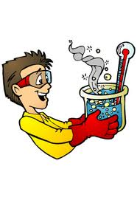

Welcome to Grade 9 Science. I hope you had a wonderful summer and are ready to dive into a new school year! You will be learning about many different and interesting topics in science. Among these we will explore the building blocks of matter, electricity, and the stars. Lastly, we will explore our selves and find out what is really involved in creating a new life!

Astronomy
Units of Study
This unit will be an exploration of the universe starting with some basic hands-on astronomy and ending with a critical look at issues surrounding space science and technology. We will also research and study Canada’s involvement in international space exploration and evaluate the risks and benefits to the human race.

Chemistry

By examining the historical development of the atomic model and the periodic table, you will become familiar with the basic building blocks of matter. Investigations of the properties of elements and compounds will acquaint you with chemical symbols and chemical families, as well as events that demonstrate chemical change.

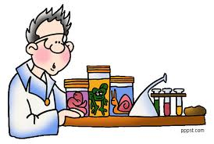
Reproduction

This unit will give students an opportunity to compare asexual and sexual reproduction. You will learn how the human reproductive system functions and will be able to describe the major stages of human development from conception to birth. You will recognize that the cell contains genetic information and is responsible for the transmission of traits from one generation to the next.

Electricity
This unit will develop the concept of the particle model of electricity as it relates to electrostatics and current electricity. We will take a historical look at some early models of electricity as well as constructing and using simple devices to investigate electrostatic phenomena. In the transition from static electricity to current electricity we will investigate circuits and make connections to daily applications such as the cost of electricity and the safety of electrical appliances.

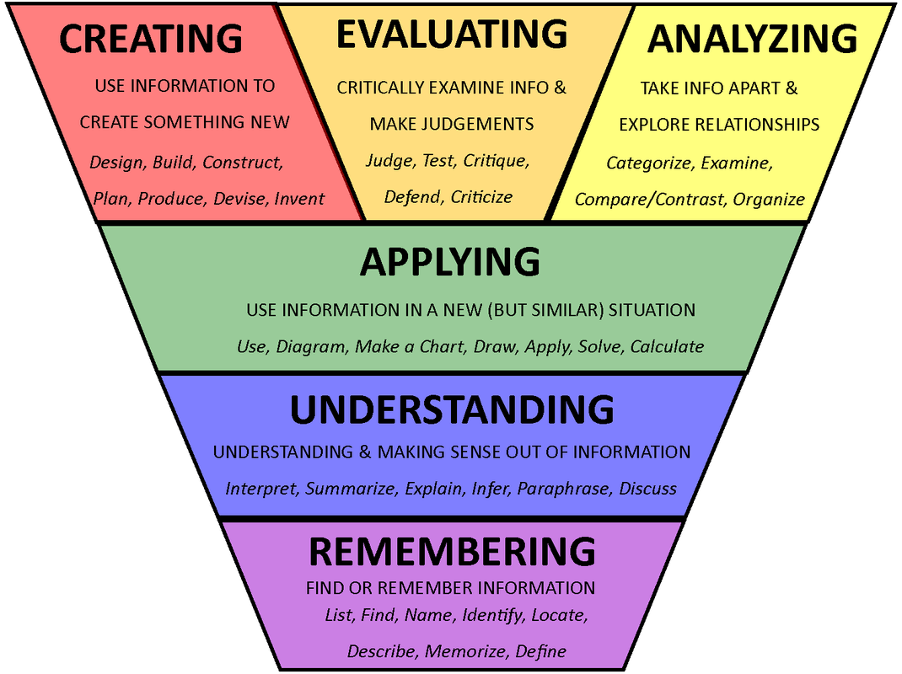
Assessment:

In 1956, Benjamin Bloom and a few of his colleagues developed what is now known as “Bloom’s Taxonomy” which, simply put, are categories of learning. These categories provide a template for how teachers organize course content and how students learn. They will be the basis for assessment in this course. The bottom two levels are Knowledge (or Remembering) and Understanding. Any
idea starts off this way beginning with definitions,
facts, memorization, descriptions and explanations. This
is learning at its most basic and introductory level. The
next two intermediate levels are Applying and Analyzing that involves applications of ideas/skills to new situations, problem solving or calculations along with comparing and contrasting, organizing and examining relevant information. Finally, Evaluating and Creating are the highest order learning categories that involve critique and judgment where new products are designed, built and tested. It also involves the communication of these products to a larger audience.
All assessments including homework, quizzes, tests, projects will be broken down into these weighted categories from which your mark will be derived:

Category Weights:

KU - Knowledge and Understanding 30%

APS - Application and Problem Solving 40%

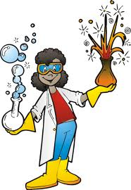
CD - Communication & Design 30%

Final Mark:

Two Terms @ 40% each

Final Examination @ 20%

Please note that categories will not be filled at the same rate throughout the course since different topics may lean heavily on one category. Furthermore, each assessment will fall into one of two categories, formative and summative. Formative assessments will be recorded but will not count towards your mark. They will be available for parental observation to demonstrate evidence of learning along with summative assessments. These assessments designed for students to measure their retention of the course content and to adjust their study focus to required weaker areas. Summative assessments are recorded and count towards your final mark. They usually come after one or more formative assessments have occurred in that area. These assessments are for teachers, students and parents to observe how well students are apprehending course outcomes.

Absences

It is expected that you will take the initiative to work ahead if you know that you will be away and/or catch up on any missed tests, quizzes, homework or notes the day you get back. It is extremely important for you to take the initiative to come and see me about what you have missed. In the case of missed notes or handouts, you can photocopy a friend’s notes or in the case of handouts get a copy from me or print one from my website. In the case of a missed lab, you will be required to perform it during one of your spares or lunch, whenever suitable.

In the case of missed quizzes or tests, expect to write it within TWO SCHOOL DAYS of returning to school. This will happen either in class or during one of your spares in the QLC, at the discretion of your instructor even if you do not have science that day! If you are away for an extended period of time, arrangements will be made accordingly. Unnecessary delay when writing a quiz or test may result in a mark deduction of 10% decided by the instructor. Should a student ask for a later test date on the day of the test or quiz without a note, this same rule might apply. `For students that have missed class due to a transfer from another course or school, they will still be expected to complete the missed work on their own time so they can write the same exam as every other student. There will be at least one test at the end of each unit; longer units may have a mid-unit test/s. All tests are cumulative, covering all topics within the unit. It is highly recommended that students keep all tests as a resource when preparing for the final exam.

Daily Life in Class

Students are given homework on a regular basis and are expected to complete their homework on time. Science is a methodical task that requires and builds on previous ideas. Current work is often largely dependent on previous lessons so it is imperative that a student keeps up to date with assignments. Submission of any assignment is penalized 10% for every school day even if we do not have class every school day. After one week, the assignment can still be submitted but will be subject to a pass/fail marking system: 50% complete and 25% incomplete. Periodic homework checks will be recorded formatively or a sample of that homework taken in for summative assessment when applicable. Notebooks are compulsory for grade nine science. I would recommend loose leaf and a binder so handouts remain in the proper place. They provide the student with a means of tracking and recording key information, homework, and demonstrations that are done in class or assigned for homework. In addition to assigned work, students are also free to record additional notes in their notebooks if they find this helpful. This book serves as a record of what we learn and do in class and thus, it must be kept organized and up to date. Periodic notebook checks may be given to monitor progress of student’s organization and completed assignments.

Academic Integrity

Guidelines for academic integrity are outlined in your agenda book. Please read this information carefully. In particular, take note of the following acts of academic dishonesty:
- Copying another student’s work for any required assignment.
- Providing another student with an assignment for the purpose of plagiarism.
- Sharing information when assignments are to be done individually.

Students who choose to plagiarize material will receive a mark of zero on the assignment, go on academic probation and parents will be informed.

Classroom Atmosphere:

The science classroom should be a cooperative, positive, respectful learning environment for all students. It is expected that each student will strive to manifest the Code of Conduct in their learning experience to achieve success not only for themselves but also for the classroom at large. 1 Cor. 10:23 “Everything is permissible," but not everything is helpful. "Everything is permissible," but not everything builds up. Example: Everyone is allowed to speak just not all at the same time! The underlying assumption is that “The teacher has the right to teach and students have the right to learn”. Anything that interferes with this will need to be addressed by the instructor. Warnings will be given and if negative behavior persists, a student may be asked to leave the classroom and/or speak to administration about their behavior with parents involved at each step.

Classroom Expectations

- Students are expected to come to class on time with the required materials, to be prepared to participate fully in all activities, and to follow the classroom rules. Students should be SEATED with books open when the second bell rings.
- The science classroom is a LABORATORY, which means we need to treat it respectfully. This means following the lab safety rules during experiments as well as no eating or drinking. The only liquid allowed in the classroom is bottled water.
- It is expected that all persons be treated with respect and courtesy in a Christ-like manner. This means respect EVERYONE, even if they are not in our class.
- Due dates will be given for all assignments and students are expected to hand in work on time. Generally, all assigned work is due the following class unless otherwise stated. Students who fall behind in their assignments will be required to spend their spares in the QLC until the outstanding assignments are completed. This may happen during the term or at the assigned assignment assistance day.
- Students who are away for any reason are responsible for finding out what assignments, homework, and notes they missed. The best way to do this is to ask the instructor and/or a friend for the missing material.

Getting Extra Help

Most often, sufficient time is given in class to complete assignments and labs. Extra time in class should be spent reviewing and studying. This extra time can also be used to ask for help. Should additional help be required, feel free to make arrangements with me so we can address your concerns as they come up.

ASSIGNMENT # 1

Please read through the course outline with your parent/guardian and have them sign the form below stating that they are familiar with the contents of the course.

Hand this page in next class for 5 marks!

NAME of STUDENT:

I have read the GRADE NINE SCIENCE course outline and am familiar with its contents.

Student’s Signature: Date:

Parent/Guardian Signature: Date:

