Grade 11 Physics Course Outline 2016-17

Instructor: Mr. Warkentine swarkentine@mbci.mb.ca

What is Physics?

Physics is simply mankind’s attempt to understand our physical universe at its most fundamental level. Richard Feynmann, the great modern physicist of our time, described physics simply as the nature of nature. To the ancient Greeks, physics (‘phusikos’) encompassed many disciplines like theology, epistemology, philosophy, astrology, etc. but in modern times, physics is more narrowly defined as attempting to explain just the physical world phenomena (although the branch of quantum mechanics blurs these lines severely!).

Physics is a discipline aimed at the pursuit of truth, a method of thinking that assumes as little as possible while demanding that we give up our preconceptions about how our world works to make room for new possibilities that explain the widest possible observable phenomena.

This course is designed to train students how to think critically about the universe with a view to understand it as deeply as possible. To do this physics employs models, many of which are mathematical. We start with Aristotle, Galileo and Newton, but we also whet your appetite for Einstein and Bohr, the fathers of quantum mechanics.

So, how hard is it to understand our physical world? Well, some of the best and brightest minds of the past and present have struggled immensely with real answers to some very elementary questions about our world. But physicists are a tenacious lot and despite some challenging obstacles, have made some incredible discoveries that have deepened our understanding both of the microscopic world and the universe at large. It is impossible to assess just how much physics has changed our world and how we, in turn, perceive it.
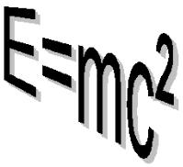
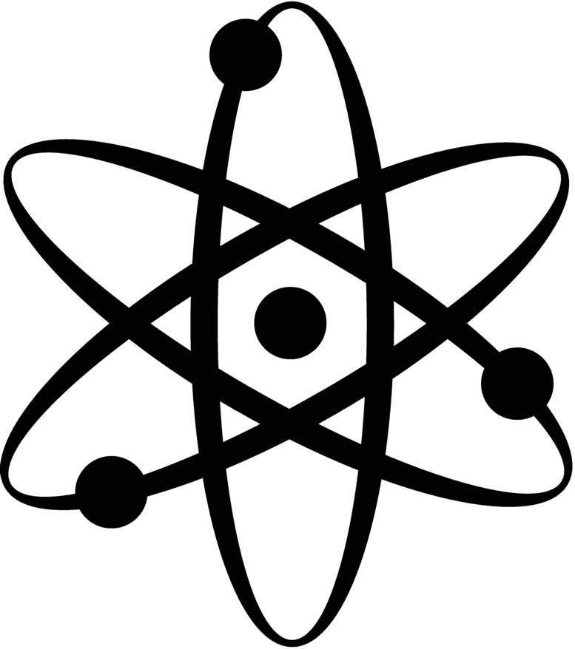

What are the topics of study?
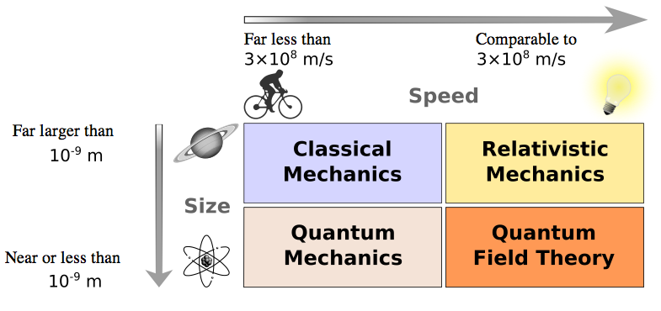

I. Classical (Newtonian) Mechanics – Term 1

A. Kinematics – Describing motion in one dimension through position, velocity and
acceleration graphically, visually, symbolically
B. Dynamics – Understanding the cause of motion (forces) in one dimension using
vectors, free body diagrams and Newton’s laws of motion

II. Fields – Term 2

A. Gravitational – Describe and calculate gravitational force using Newton’s law both regionally ‘g’ and universally ‘G’.
B. Electrical – Describe and quantify electrical force. Diagram electrical
fields. Discover the elementary charge through Millikan’s experiment.
C. Magnetic – Diagram magnetic fields and describe the origin of magnetism and
Its related phenomena
D. Electromagnetism – Study the relationship between electricity and magnetism
with its extensive applications in today’s society

III. Waves – Term 2

A. Waves in One Dimension – Basic wave characteristics and behavior
B. Waves in Two Dimensions – interference patterns and their applications
C. Sound Waves – Propagation and resonance, musical scales
IV. The Nature of Science (time permitting/integrated throughout course)

A. Models, Laws and Theories – the growing body of scientific knowledge and its
tentative nature
B. The Particle/Wave Model of Light – evidence for light’s dual nature

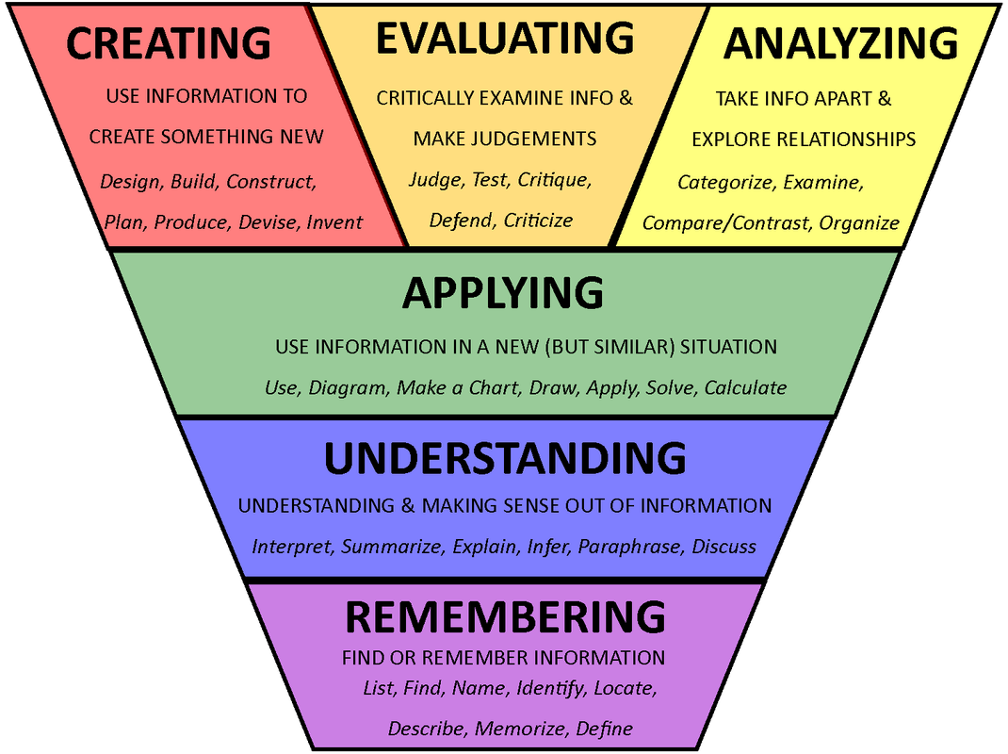
How are marks earned?

Assessment:

In 1956, Benjamin Bloom and a few of his colleagues developed what is now known as “Bloom’s Taxonomy” which, simply put, are categories of learning. These categories provide a template for how teachers organize course content and how students learn. They will be the basis for assessment in this course. The bottom
two levels are Knowledge or Remembering and Understanding. Any idea starts off this way and
begins with definitions, facts, memorization, descriptions and explanations. This is learning at its
most basic level. The next two intermediate levels are
Applying and Analyzing that involve applications of ideas/skills to new situations, problem solving or calculations along with comparing and contrasting, organizing and examining relevant information. Finally Evaluating and Creating are the highest order learning categories that involve critique and judgment where new products are designed, built and tested. It also involves the communication of these products to a larger audience.
This means that your homework, quizzes, tests, projects will be broken down into these weighted categories from which your mark will be derived:

Knowledge and Understanding – KU 30%

Application and Problem Solving – APS 40%

Communication & Design – CD 30%

Please note that categories will not be filled at the same rate throughout the course since different topics may lean heavily on one category. Remember, there are no terms so we need not worry about ‘filling up’ a category before certain deadlines. However, there will be a midyear mark reporting time after which work from the former part of the course does not count for the latter.
Furthermore, assessments will fall into formative and summative. Formative assessments will be recorded but will not count towards your mark but are available for parental observation. They are assessments designed for students to measure their retention of the content of the course and to adjust their study focus to required areas. Summative assessments are recorded and count towards your final mark. They usually come after one or more formative assessments in that area. These assessments are for teachers, students and parents to observe how well students are learning the course objectives.
How does one excel at Physics?

Students who excel at physics generally possess these attributes to varying degrees:
- Humility – a willingness to change or give up an idea that does not fit with experimental results based on sound logic
- Curiosity & Creativity – being able to approach problems from different aspects and/or using available tools in new ways to achieve specific goals
- Tenacity – an unwillingness to give up despite adverse or difficult circumstances
- Problem Solving Ability – understanding problems properly as well as developing and executing a plan to solve it accurately and efficiently
- Mathematical Ability – specifically algebraic and computational skills
“Mathematics is the alphabet with which God has written the universe” - Galileo Galilei

These five elements are essential pillars in building a good Physical understanding of our universe. Perhaps you lack a proficiency in one area but you make up for it in another. It is interesting to note that the first three of these pillars are attitudes which you bring to the course. Physics is not passive endeavor but an active one. The last two are skills that require continual sharpening. So then, physics then is both an art (attitudes) and a science (skills). Unlike other courses, physics topics do not necessarily build on each other. The topics are discrete with some overlap. This means that physics requires a lot of ‘head space’. Be prepared for this. You have been studying math since you were in kindergarten but you have only been studying physics since grade 10 in depth. If you struggle, study and read over related notes and/or the worked examples that we have written in our notes. Read the appropriate section in the textbook. Seek advice from friends and continue to ask questions in class and come see me for extra help. Try to be preemptive with major difficulties in the course work - the day before a quiz or test is too late!

What can I expect from Physics each day?

Daily Lessons:
Most of the concepts are taught through lectures where notes are given or they are written down along with handouts, activities and labs that require a student to focus their attention for maximum learning. Each lesson is designed in a very specific way so that you are led through a critical thinking process to understand the concept. An introduction to a concept usually starts with some form of a demonstration, illustration or activity which develops the main idea with practice to follow when applicable. Sometimes it is a skill or calculation, and other times it is an explanation or historical thread. At any rate active listening is required and a willingness to allow your thoughts to ponder and grasp new concepts.

Assignments:
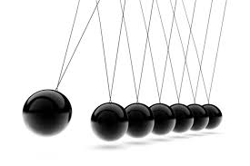

Physics is a skill based course focused on problem solving. These problems require practice even if the concept itself is clear. It is extremely important to keep current with the assigned questions given. Lagging behind makes the content in class all the more confusing which breeds an overwhelming frustration and despair. Random homework checks will be given on a formative basis. Show all work for full marks, because I cannot read your mind. Cramming for physics is a lot to ask of any student and is NOT RECOMMENDED as a study practice. If you are in trouble, let me know so we can work at fixing it right away. The typical day will be comprised of a lecture and/or demonstration for about two thirds of the class with the latter given for time to work on the related assignment, project or lab. This varies however, depending on what we cover that day. Some lessons will take the whole class so be prepared for that.

Any work other than homework (labs, projects, major assignments) must be submitted in a clear folder (not duotang type). If it is not received during the class it is due will be subject to a 10% grade reduction per school day. After one school week, any major assignments, labs or projects received will be given a 50% (satisfactorily complete) or 25% (unsatisfactorily incomplete) grade based upon the instructor's discretion. This type of marking will be utilized mostly for the AAD, the day at the end of the term for all unfinished work.

Labs:

Labs are usually done together as a group of two or possibly three but, unless otherwise noted, a unique copy of the lab is required for each individual. Although the purpose, apparatus, and quantitative observations will be the same, the qualitative observations, discussion and conclusion should be the original work of the student who handed it in. Please review the outline of what plagiarism is and its academic penalty from you student handbook to clarify. Make sure you choose lab partners that you think can work as thoroughly and diligently as you can. Marks will not be prorated after the fact in light of a perceived ‘unequal’ yoking among a lab group.
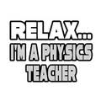

Projects:

Projects are similar to labs and as such entail the same recommendations about choosing partners as above. Since projects are completed over such large periods of time, milestones and checkpoints for assessment are needed to ensure work progresses evenly and does not put the group into unnecessary stress due to lack of time. Time management skills are an absolute must for engineers. Being able to practice this is excellent for future projects in university and career. The biggest project this year is of course the spaghetti bridge project which will be completed

What do I need to bring every day to class?

Besides the attitudes conducive to learning outlined above, you are expected to bring a binder, a scientific or graphing calculator, pens and/or pencils, ruler and protractor. When you hand in your homework each test, you will need a slim clear plastic folder. Have two ready to go at any time. If you come to class without necessary materials to learn and come after the bell you will be marked late.
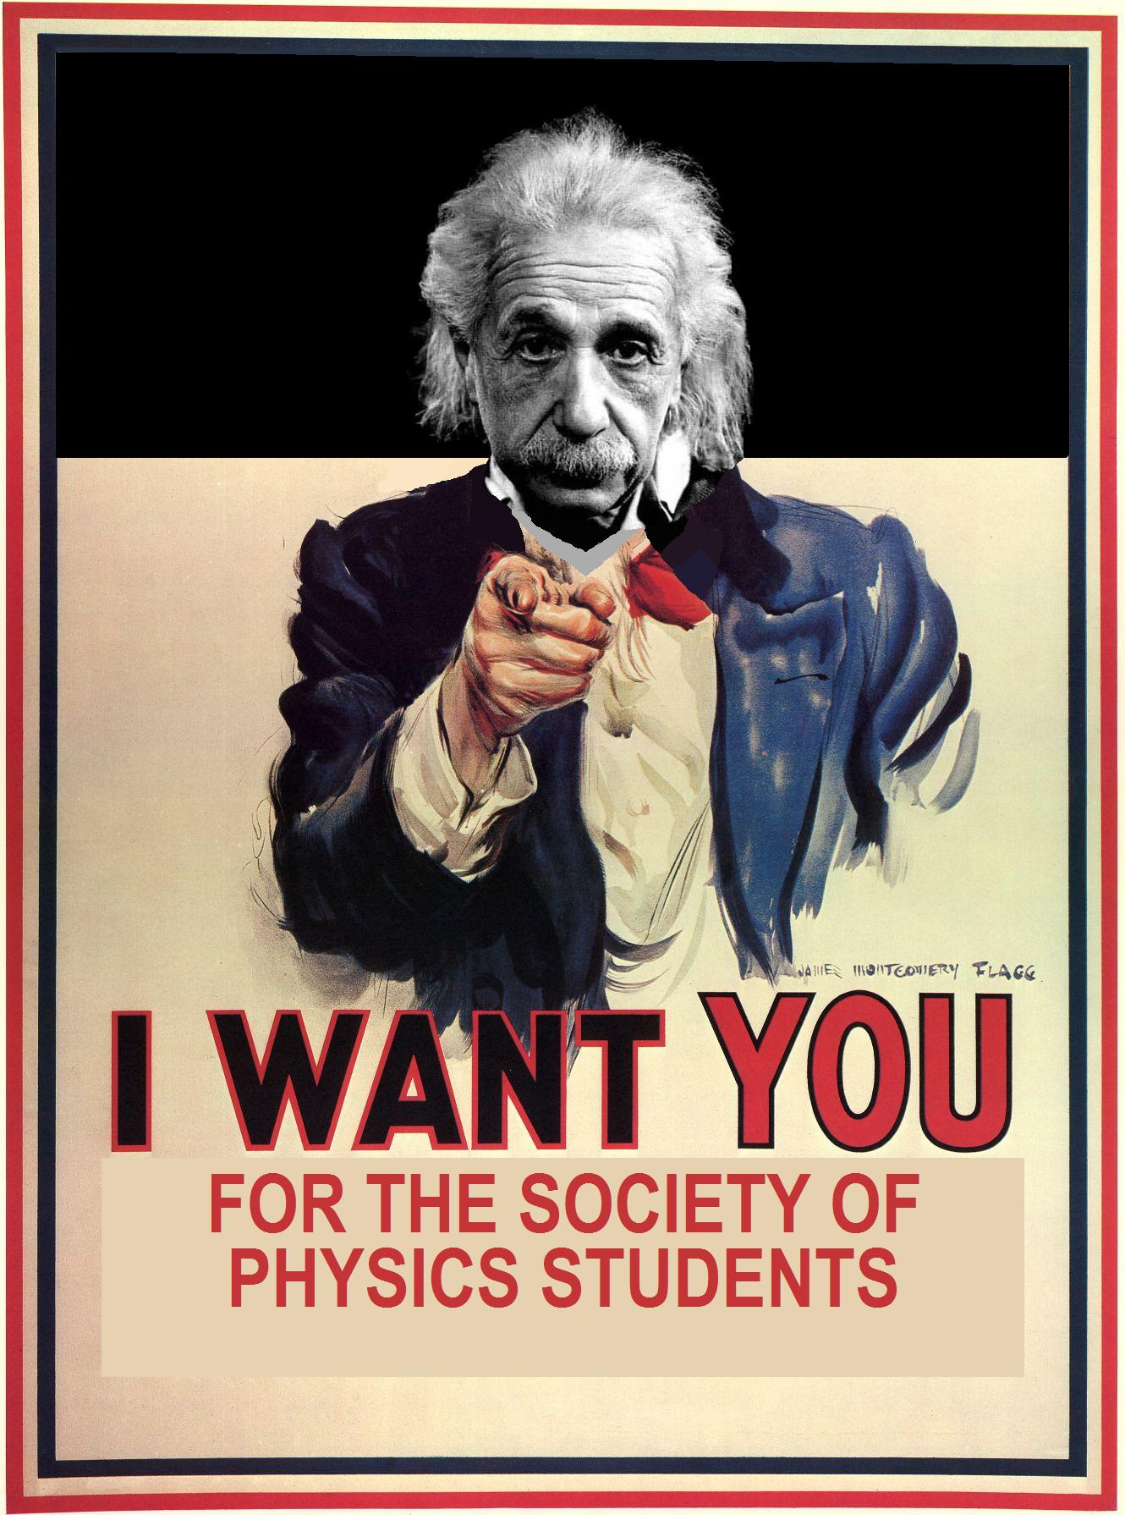
What is the atmosphere like in Physics?

The science classroom should be a cooperative, positive, respectful learning environment for all students. It is expected that each student will strive to manifest the Code of Conduct in their learning experience to achieve success not only for themselves but for the classroom at large. 1 Cor. 10:23 “Everything is permissible," but not everything is helpful. "Everything is permissible," but not everything builds up. Example: Everyone is allowed to speak just not all at the same time! The underlying assumption is that “The teacher has the right to teach and students have the right to learn”. Anything that interferes with this will need to be addressed by the instructor. Warnings will be given and if negative behavior persists, a student may be asked to leave the classroom and/or speak to administration about their behavior with parents involved at each step. The Guidelines for Positive School Life provide an excellent framework for a dynamic, successful learning atmosphere. Some common sense about general expectations is also helpful. Listen carefully and keep detailed notes so you have something to study for tests and quizzes. Clarify understanding before it grows into a larger problem. Be diligent with homework. Respect the instructor and peers and allow yourself to be lead in new directions.

What if I miss a class?

Absences:

It is expected that you will take the initiative to work ahead if you know that you will be away and/or catch up on any missed tests, quizzes, homework or notes the day you get back. It is extremely important for you to take the initiative to come and see me about what you have missed. In the case of missed notes or handouts, the notes can be photocopied from a friend and the handouts will be available in class or in available on EDSBY. In the case of a missed lab, you will be required to perform it during one of your spares or lunch, whichever is suitable. In the case of missed quizzes or tests, expect to write it within two school days of when you get back. If gone for an extended period of time either in class or during one of your spares in the QLC, whichever your instructor decides, even if you do not have Physics that day! ! If you are away for an extended period of time, arrangements will be made accordingly. Unnecessary delay when writing a quiz or test may result in a mark deduction of 10% decided by the instructor. Should a student ask for a later test date on the day of the test or quiz without a note, this same penalty might apply. Unnecessary delay when writing a quiz or test will result in a minimum mark deduction of 10% at the discretion of the instructor. For students that have missed classes due to a transfer from another course or school, they will still be expected to complete the missed work on their own time so they can write the same exam as every other student. There will be at least one test at the end of each unit, longer units may have a mid-unit test/s. All tests are cumulative, covering all topics within the unit. It is highly recommended that students keep all tests as a resource when preparing for the final exam.

Do you recommend any websites that would be helpful for this course?

There is a lot of information on the Internet about physics but not all of it is helpful for Grade 11 Physics. I have found these sites to be pertinent and helpful. Use these as a start to explore the world of physics. If you find any others that are helpful for this course or of are particular interest, please let me know!

hyperphysics.phy-astr.gsu.edu/hbase/hframe.html
surendranath.tripod.com/Applets.html
www.physicsclassroom.com
www.physics.org
Youtube channels: Veritasium, Smarter Every Day, Minute Physics, Vsauce

ASSIGNMENT # 1

Please read through the course outline with your parent/guardian and have them sign the form below stating that they are familiar with the contents of the course.

Hand this page in next class for 5 marks!

NAME of STUDENT:

I have read the GRADE 11 Physics course outline and am familiar with its contents.

Student’s Signature: Date:

Parent/Guardian Signature: Date:

