Science 20F Course Outline

Instructor: Mr. Warkentine swarkentine@mbci.mb.ca

Science is the search for relationships that explain and predict the natural world. Modern science assumes there are patterns, laws and principles that govern out universe waiting to be uncovered through careful, rational experimentation. What emerges is a beautiful tapestry of knowledge that we have used to understand our world, making it a safer, healthier and more enjoyable place to live. This course will explore some of these established patterns and hopefully ignite a keen interest and curiosity in science while preparing you for sciences in grade 11.

“God is in the details” – Ludwig Mies van der Rohe

# https://encrypted-tbn3.gstatic.com/images?q=tbn:ANd9GcQdBAz75pzMMnMedsIBQAcyN1tgADVmVPzUH5164uWZw4XQERHdxwCourse Content: (See Specific Outcomes HO for greater detail)

## Unit 1 - Chemical Processes - This unit examines why and how elements form compounds. The foundation for the naming (nomenclature) and formation of molecular and ionic compounds is laid along with balancing chemical equations, recognizing major reactions types and examining some properties of acids and bases.



**Unit 2 - Motion –** The motion of objects is studied within the context of the automobile. The history of motion along with the relationship between displacement, velocity, time and acceleration is analyzed both descriptively and mathematically. These models are not only used to describe and explain motion observed in our everyday life but also justify the safety features in automobiles designed to reduce fatalities and injuries in the event of a collision.



**Unit 3 - Weather Dynamics -** This unit is aimed at understanding the key factors that determine weather and climate both locally and globally. Meteorological data is analyzed with respect to water and heat transfer cycles. Severe weather events and their impact on society are explored as well as issues of human activity that influence global climate.

**Unit 4 – Sustainability of Ecosystems –** Ecology is the interaction between living things and their environment, which is the main focus of this unit as it relates to sustainability. The study of biological and chemical cycles, toxin accumulation in food chains is examined. In addition, population changes within ecosystems is investigated along with Earth’s amazing biodiversity. As we do so we can make informative decisions to preserve and sustain our ecosystems in a more meaningful and deliberate way.

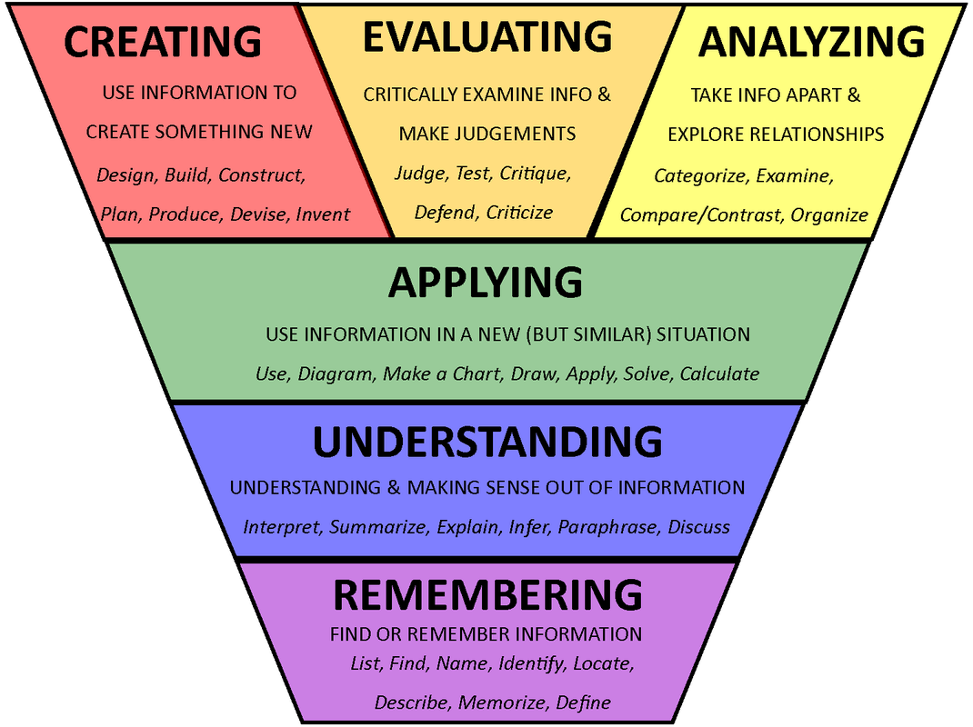**Assessment:**

A man named Benjamin Bloom and a few of his colleagues developed what is now known in education circles as “Bloom’s Taxonomy” which, simply put, are categories of learning. These categories provide a template for how teachers organize course content with respect to how students learn. They will be the basis for assess-ment in this course. The bottom two levels are **Knowledge (or Remembering) and Understanding**. Any

idea starts off this way beginning with definitions,

facts, memorization, descriptions and explanations. This

is learning at its most basic and introductory level. The next two intermediate levels are **Applying and Analyzing** that involve applications of ideas/skills to new situations, problem solving or calculations along with comparing and contrasting, organizing and examining relevant information. This is the intermediate stages of learning. Finally, **Evaluating and Creating** are the highest order learning categories that involve critique and judgment where new products are designed, built and tested. It also involves the communication of these products to a larger audience.

Any assessment including homework, quizzes, tests, projects will be broken down into these weighted categories from which your mark will be derived:

**Category Weights:**

**KU - Knowledge and Understanding**  30%

**APS - Application and Problem Solving** 40%

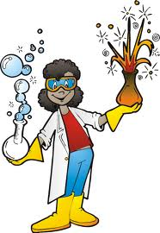**CD - Communication & Design**  30%

**Final Mark Weights:**

**Two Terms @ 40% each**

**Final Examination @ 20%**

Please note that categories will not be filled at the same rate throughout the course since different topics may lean heavily on one category. Furthermore, each assessment will fall into one of two categories, **formative and summative**. Formative assessments will be recorded but will not count towards your mark. They will however be available for parental observation to demonstrate evidence of learning along with the summative assessments. They are assessments designed for students to measure their retention of the course content and to adjust their study focus to required weaker areas. Summative assessments are recorded and count towards your final mark. They usually come after one or more formative assessments have occurred in that area. These assessments are for teachers, students and parents to observe how well students are apprehending course outcomes.

**Absences:**

It is expected that you will take the initiative to work ahead if you know that you will be away and/or catch up on any missed tests, quizzes, homework or notes the day you get back. It is extremely important for you to take the initiative to come and see me about what you have missed. In the case of **missed notes or handouts**, the notes can be photocopied from a friend and the handouts will be available in class or available on EDSBY. In the case of a **missed lab**, you will be required to perform it during one of your spares or lunch, whichever is suitable. In the case of **missed quizzes or tests**, expect to write it within two school days of when you get back. If gone for an extended period of time either in class or during one of your spares in the QLC, whichever your instructor decides, **even if you do not have science that day**! ! If you are away for an extended period of time, arrangements will be made accordingly. Unnecessary delay when writing a quiz or test may result in a mark deduction of 10% decided by the instructor. Should a student ask for a later test date **on the day of the test or quiz without a note**, this same penalty might apply. Unnecessary delay when writing a quiz or test will result in a minimum mark deduction of 10% at the discretion of the instructor. For students that have missed classes due to a transfer from another course or school, they will still be expected to complete the missed work on their own time so they can write the **same** exam as every other student. There will be at least one test at the end of each unit, longer units may have a mid-unit test/s. All tests are cumulative, covering all topics within the unit. It is highly recommended that students keep all tests as a resource when preparing for the final exam.

**Assignments:**

Unless otherwise stated, assume assignments or homework are due the next class after being assigned. Partial marks may be awarded if work is completed after due date at the discretion of the instructor. Major assignments or projects that are received past the due date will be subject to a 10% penalty **per school day**. After a week, any work received will be marked a pass (complete - 50%) or a fail (incomplete - 25%). The 25% incomplete rule cannot be used more than once a school year for major assignments equal to or exceeding 20% of the term mark. Students may be asked to complete overdue assignments in the QLC during available spares if they fall too far behind. All term work must be submitted within that term to receive credit. All assignments must be handed in to the INBOX, a plastic container labeled “Mr. Warkentine’s IN BOX” found on the **front desk.** Sliding work under my door or leaving it on somewhere on my desk is not an acceptable way to hand any work in. Major assignments must be handed in a clear folder of my description with a title page containing a name, date, instructor’s name, title and date.

Class Preparation:

You are expected to bring your textbook, a binder, a scientific calculator, ruler and sufficient writing utensils for each class. Occasionally you will need to use a slim clear folder for notebook and assignment submissions. Have at least two handy at all times. If you need to borrow materials from the instructor for a test or quiz, marks will be deducted from your overall score. If you have to go back to your locker for materials and enter the class after the second bell you will be marked late.

Classroom Atmosphere:

The science classroom should be a cooperative, positive, respectful learning environment for all students. It is expected that each student will strive to manifest the Code of Conduct in their learning experience to achieve success not only for themselves but for the classroom at large. 1 Cor. 10:23 “Everything is permissible," but not everything is helpful. "Everything is permissible," but not everything builds up. Example: Everyone is allowed to speak just not all at the same time! The underlying assumption is that “The teacher has the right to teach and students have the right to learn”. Anything that interferes with this will need to be addressed by the instructor. Warnings will be given and if negative behavior persists, a student may be asked to leave the classroom and/or speak to administration about their behavior with parents involved at each step.

**Classroom Expectations:**

1. Be in class, in your seat, waiting with your books open, ready for instruction **before** the second bell rings. Make sure to bring all required materials, and completed homework to every class.
2. Since our classroom is a **lab** there will be no food or drink (other than water) allowed.
3. During labs it is vital that all lab rules, as outlined before the lab, are followed. Since this is a serious safety issue any failure to follow the safety rules will result in the student being asked to leave the room. To make up for the missed lab the student will be required to complete an alternate assignment, or receive a zero on the lab. Future participation in labs may also be in jeopardy.
4. It is expected that class time will be used wisely, and effectively. This will minimize the amount of work you will have to do at home.
5. Treat everyone in the class: students, teachers, substitutes, guest speakers, etc. with respect and courtesy.
6. The use of technology in the classroom is meant for learning, not for entertainment. If a student cannot abide by this rule, the device, (phone, tablet, laptop, etc) may be taken away temporarily.

**Academic Integrity:**

Guidelines for academic integrity are outlined in your agenda book. Please read this information carefully. In particular, take note of the following acts of academic dishonesty:

* Copying another student’s work for any required assignment.
* Providing another student with an assignment for the purpose of plagiarism.
* Sharing information when assignments are to be done individually.

Students who choose to plagiarize material:

* Will receive a mark of zero on the assignment
* Will go on academic probation
* Parents will be informed

**Extra Help:**

If class time is used well, most students should have little trouble completing most of the course work in class. Extra time in class is a good time to review material, and get help in areas that are not clear on. If you need additional help, outside of class time, please be sure to talk to me so that we can set up an appointment for extra help. This will be either before school, spares or at lunch. It is important to identify which areas you need help in, and address these areas as quickly as possible. Be proactive. Do not let it all pile up until before a test, it may be too late if you wait.

Resources:

To assist you at achieving success at science, you need to be aware of the resources at your disposal. Class time is of course your best resource, listening attentively, concentrating, asking questions, participating in discussion, putting energy into the learning process while instruction is taking place. Take advantage of class time for homework. Saying that you just ‘don’t do homework in class’ is not a valid reason for refusing to work in class and distracting others from their work. If you already know you struggle with science you may want to ask to sit beside a friend who excels at science. Come talk to me and we may be able to incorporate your suggestion into the seating plan. I am always here to assist you in or outside of class for those more difficult concepts or ideas. We can always arrange a time when needed. Your text book is another way to ‘shore up’ your understanding. It can explain things from different perspectives which can aid understanding immensely. Student Services is another way in which to get the help you need with peer tutoring or one on one study.

Cool Stuff:

Some cool websites, YouTube channels:

physicsclassroom.com

Veritasium

Minute Physics

VSauce

HowStuffWorks

**ASSIGNMENT # 1**

Please read through the course outline with your parent/guardian and have them sign the form below stating that they are familiar with the contents of the course.

Hand this page in next class for 5 marks!

NAME of STUDENT:

**I have read the GRADE TEN SCIENCE course outline and am familiar with its contents.**

Student’s Signature: Date:

Parent/Guardian Signature: Date: